**Lab Assignment**

**Object Oriented Programming**

**SHUBHAM GARG**

**9919103057**

**F2**

QUESTION 1.

#include<iostream>

#include<string.h>

using namespace std;

class bank_account

{

public:

char name_depositor[20];

int acc_no;

char acc_type[20];

float balance;

bank_account()

{

strcpy(name_depositor,"Shubham");

acc_no = 9919103057;

strcpy(acc_type,"Savings");

balance = 8893.50;

}

void deposit(float amount)

{

balance += amount;

}

void withdraw(float amount)

{

balance -= amount;

}

void display()

{

cout<<"F2 Bank Of India\n";

cout<<"NAME: "<<name_depositor<<endl<<"BALANCE: "<<balance<<endl;

}

};

int main()

{

bank_account obj1;

float deposit,withdraw;

cout<<"Enter the amount you want to deposit\n";

cin>>deposit;

cout<<"Enter the amount you want to withdraw\n";

cin>>withdraw;

obj1.deposit(deposit);

obj1.withdraw(withdraw);

obj1.display();

cout<<"Account Holder : ";

cout<<obj1.name_depositor<<endl;

cout<<"Account number :";

cout<<obj1.acc_no<<endl;

cout<<"Account type :";

cout<<obj1.acc_type<<endl;

cout<<"Account Balance :\n";

cout<<obj1.balance<<endl;

cout<<"Amount Deposited:";

cout<<deposit<<endl;

obj1.deposit(deposit);

obj1.display();

cout<<"Amount Withdrawn :";

cout<<withdraw<<endl;

obj1.withdraw(withdraw);

obj1.display();

return 0;

}

**OUTPUT :**

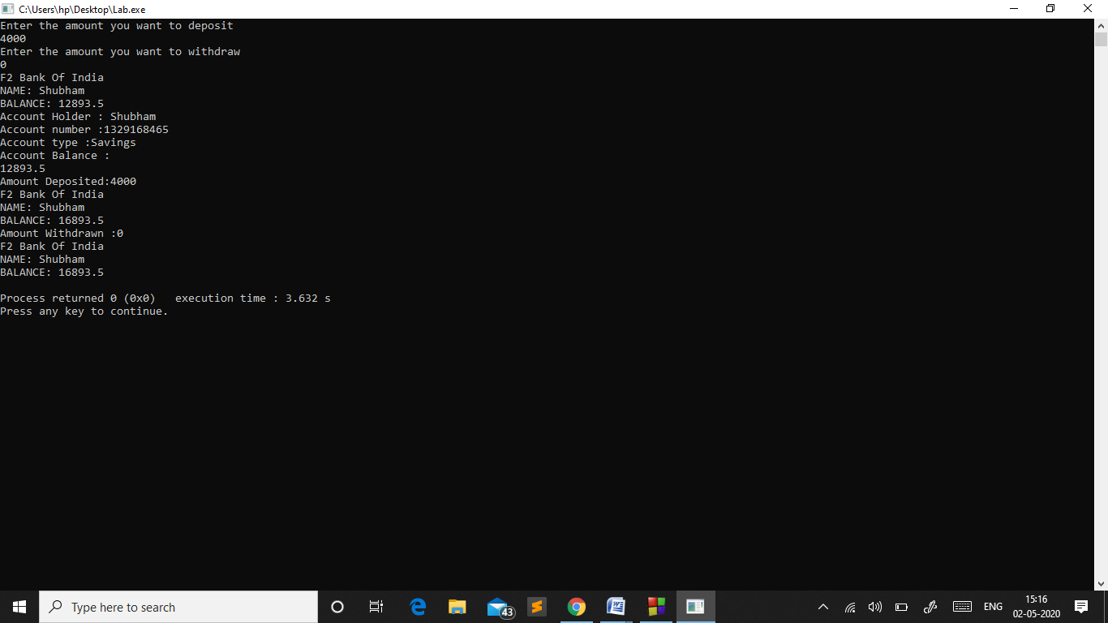

Question 2:

#include<iostream>

#include<string.h>

using namespace std;

class rectangle

{

public:

int Height,Width;

char Color[20];

int siz;

rectangle()

{

Height = 10;

Width = 20;

strcpy(Color, "blue");

siz = 20;

}

rectangle(int size)

{

Height = size;

Width = size;

strcpy(Color, "black");

siz = size;

}

rectangle(int height,int width)

{

Height = height;

Width = width;

strcpy(Color, "blue");

siz = 30;

}

rectangle(int height,int width,char *color)

{

Height = height;

Width = width;

strcpy(Color,color);

siz = 25;

}

rectangle(rectangle const &otherrectangle)

{

Height = otherrectangle.Height;

Width = otherrectangle.Width;

siz = otherrectangle.siz;

strcpy(Color, otherrectangle.Color);

}

void set(char *color)

{

strcpy(Color,color);

}

void set(int size)

{

siz = size;

}

void set(int height,int width)

{

Height = height;

Width = width;

}

void set(int height, int width,char *color)

{

Height = height;

Width = width;

strcpy(Color, color);

}

void display()

{

cout<<"HEIGHT: "<<Height<<endl<<"WIDTH: "<<Width<<endl;

cout<<"COLOR: "<<Color<<endl<<"SIZE: "<<siz<<endl;

}

};

int main()

{

rectangle obj = rectangle();

char c[20];

obj.display();

rectangle obj1 = rectangle(10);

obj1.display();

rectangle obj2 = rectangle(5,20);

obj2.display();

strcpy(c,"brown");

rectangle obj3 = rectangle(5,30,c);

obj3.display();

rectangle obj4(obj);

obj4.display();

strcpy(c,"black");

obj.set(c);

obj.set(2,10);

obj.set(3);

strcpy(c,"skyblue");

obj.set(6,20,c);

obj.display();

return 0;

}

OUTPUT :

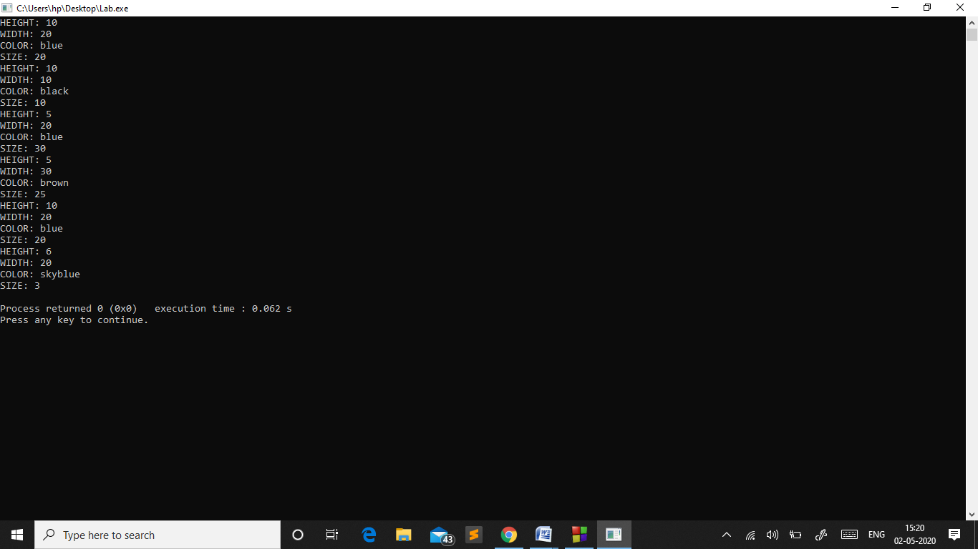

Question 3:

#include<iostream>

#include<string.h>

#include<ctime>

using namespace std;

class message

{

public:

char from[20],to[20],text[200];

int time_stamp;

message()

{

cout<<"Enter the name of the sender\n";

gets(from);

cout<<"Enter the name of the receiver\n";

gets(to);

time_stamp=1;

}

void append(char *string)

{

strcpy(text, string);

}

void display()

{

cout<<"PRINTING THE ENTERED DETAILS";

cout<<"SENDER: ";

puts(from);

cout<<endl<<"RECEIVER: ";

puts(to);

cout<<endl<<"TIME: "<<time_stamp<<endl;

cout<<"MESSAGE: ";

puts(text);

cout<<endl;

}

};

int main()

{

message obj;

cout<<"Enter the message\n";

gets(obj.text);

obj.append(obj.text);

obj.display();

return 0;

}

OUTPUT :

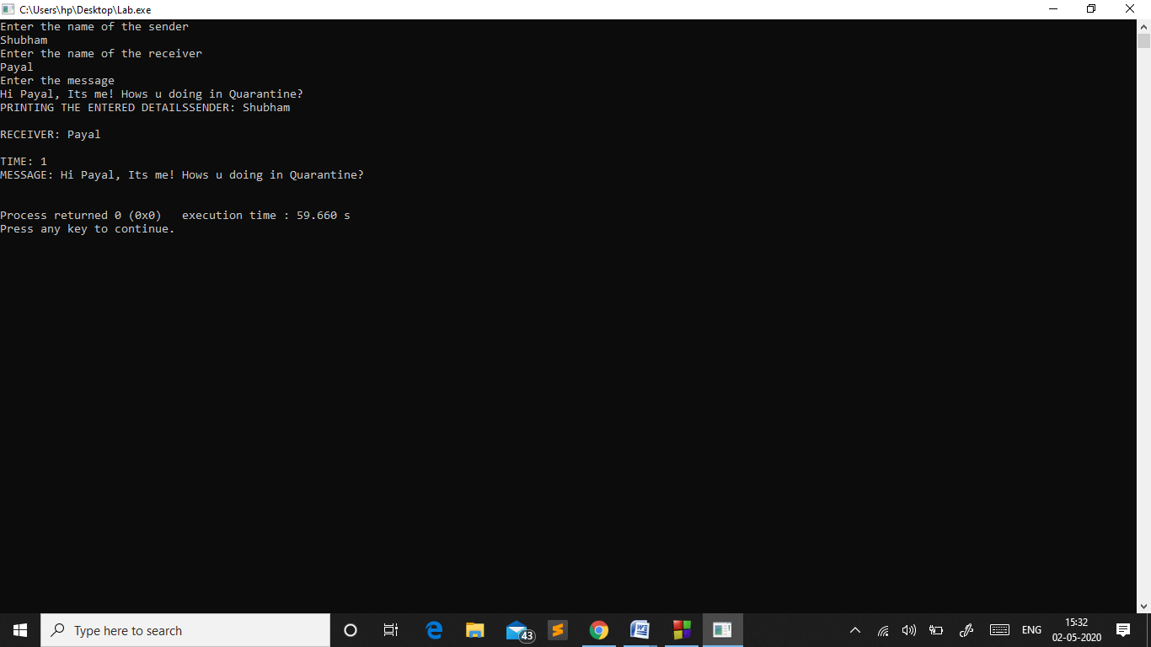

Question 4:

#include<iostream>

#include<string.h>

using namespace std;

class student

{

public:

char name[20];

int rollno,semester;

student()

{

}

student(char *stname, int rn, int sem)

{

strcpy(name,stname);

rollno = rn;

semester = sem;

}

student(student const &otherstudent)

{

strcpy(name, otherstudent.name);

rollno = otherstudent.rollno;

semester = otherstudent.semester;

}

};

void checkname(char *name1, char *name2)

{

if(strcmp(name1,name2)==0)

{

cout<<" MATCHES\n";

}

else

{

cout<<" NOT MATCHES\n";

}

}

void checkroll(int value1,int value2)

{

if(value1 == value2)

{

cout<<" MATCHES\n";

}

else

cout<<" NOT MATCHES\n";

}

void checksem(int value1,int value2)

{

if(value1 == value2)

{

cout<<" MATCHES\n";

}

else

cout<<" NOT MATCHES\n";

}

int main()

{

student s1;

strcpy(s1.name, "Shubham");

s1.rollno = 9919103057;

s1.semester = 2;

student s2;

cout<<"ENTER THE NAME OF THE STUDENT\n";

gets(s2.name);

cout<<"ENTER THE ROLL NUMBER OF THE STUDENT\n";

cin>>s2.rollno;

cout<<"ENTER THE SEMESTER\n";

cin>>s2.semester;

student s3(s1);

cout<<"CHECKING IF NAMES ARE SAME\n";

checkname(s1.name,s3.name);

cout<<"CHECKING IF ROLL NUMBERS ARE SAME\n";

checkroll(s1.rollno,s3.rollno);

cout<<"CHECKING IF SEMESTERS ARE SAME\n";

checksem(s1.semester,s3.semester);

return 0;

}

OUTPUT :

